5,6:

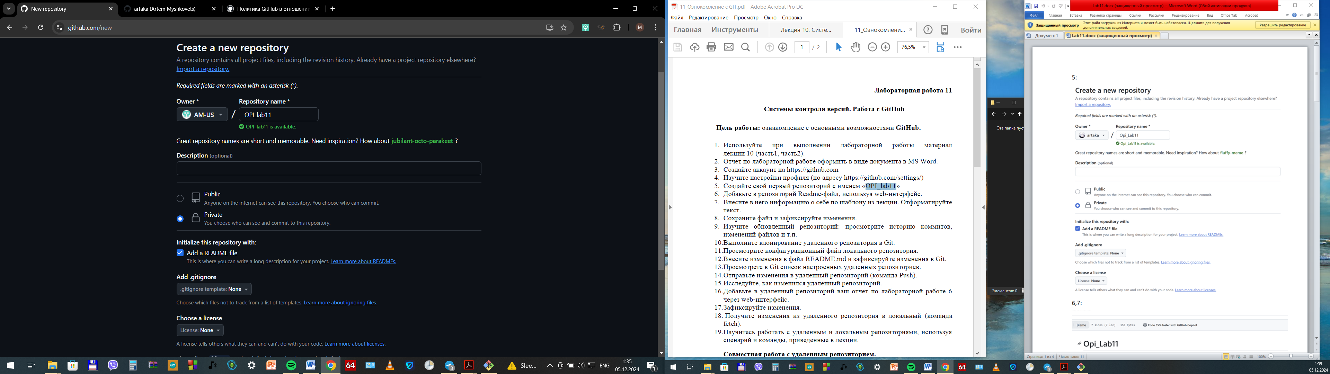

7,8:

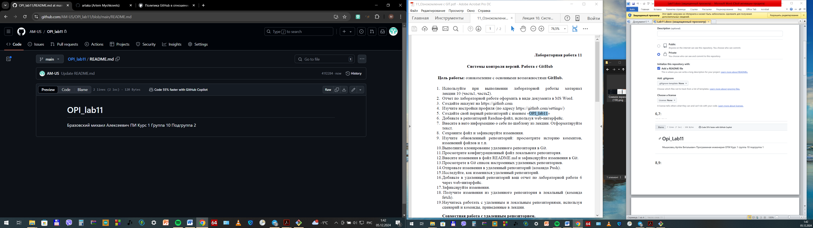

9:

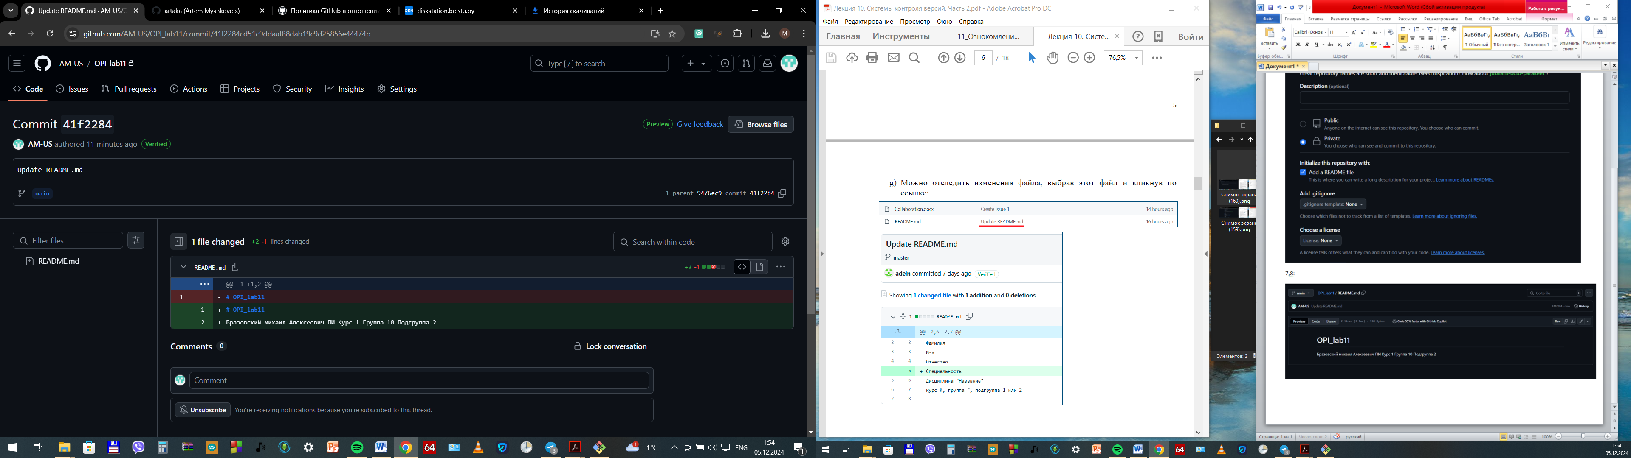

10: 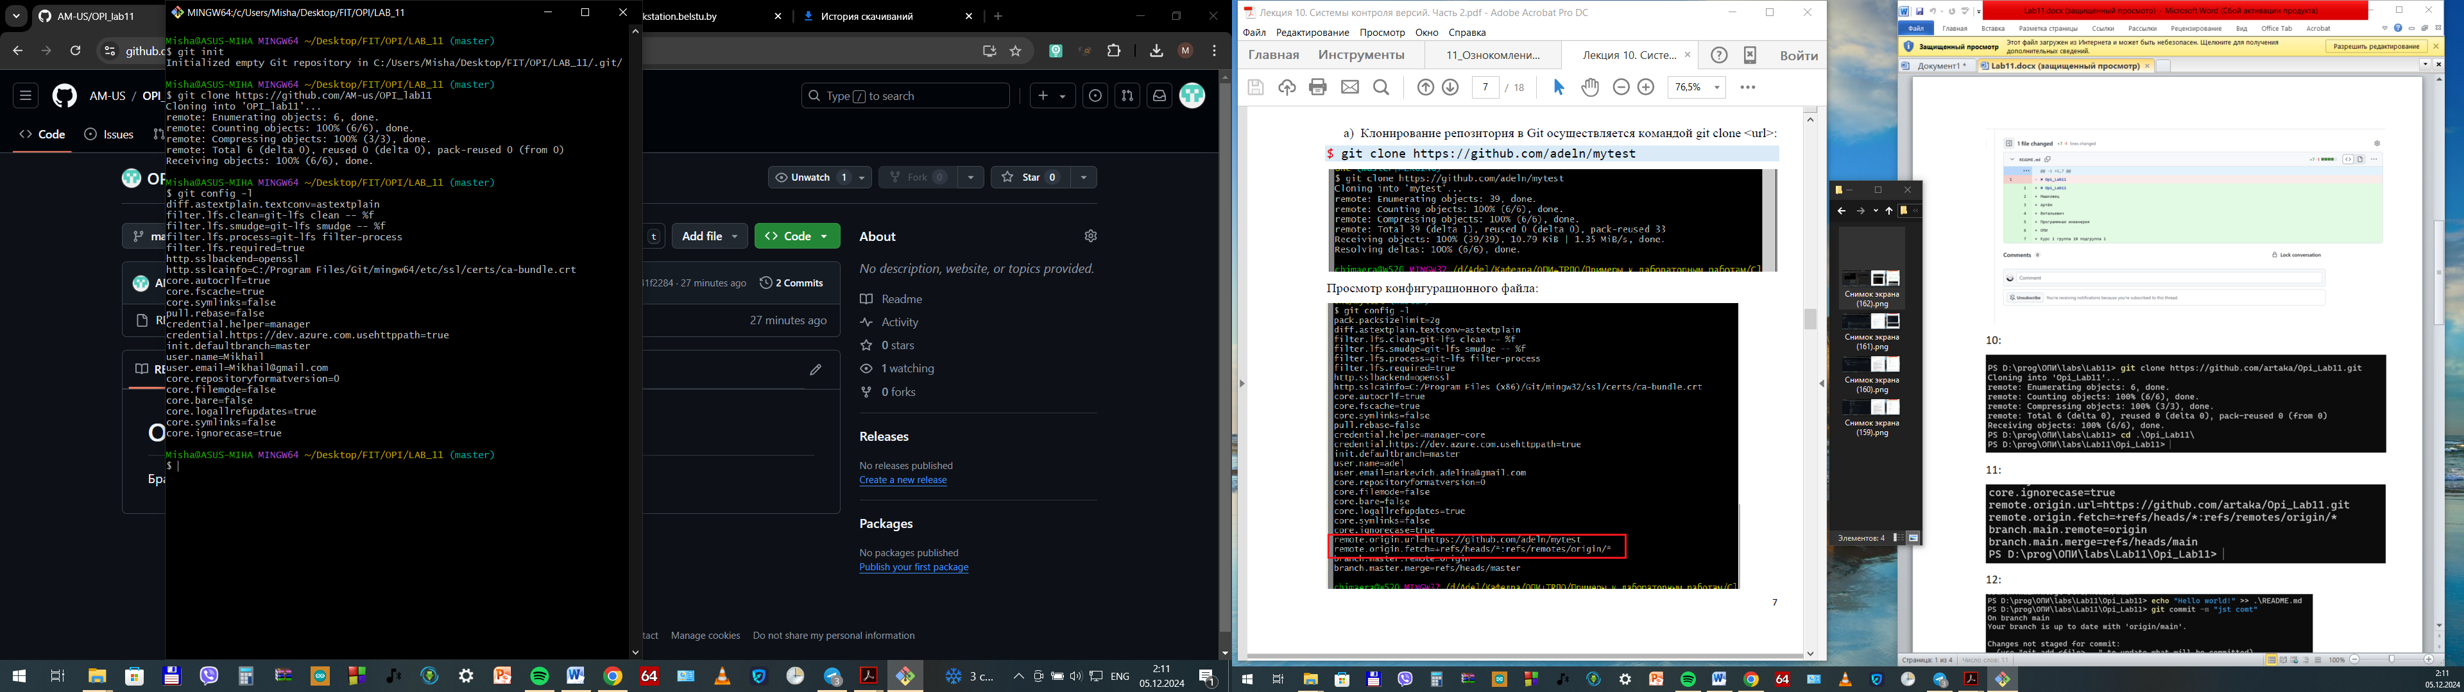

11

11: 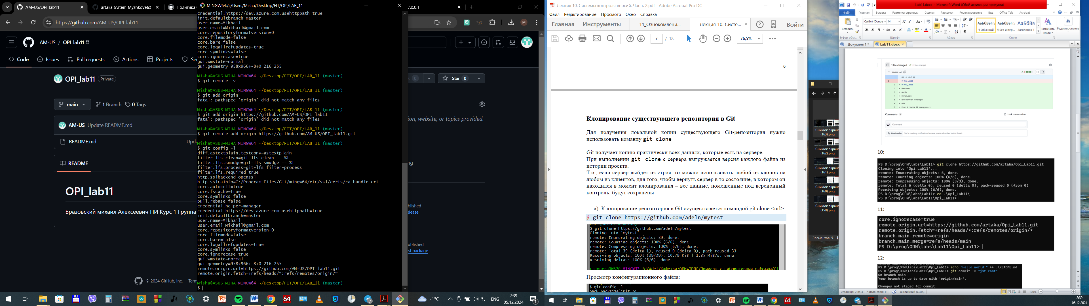

12

12:

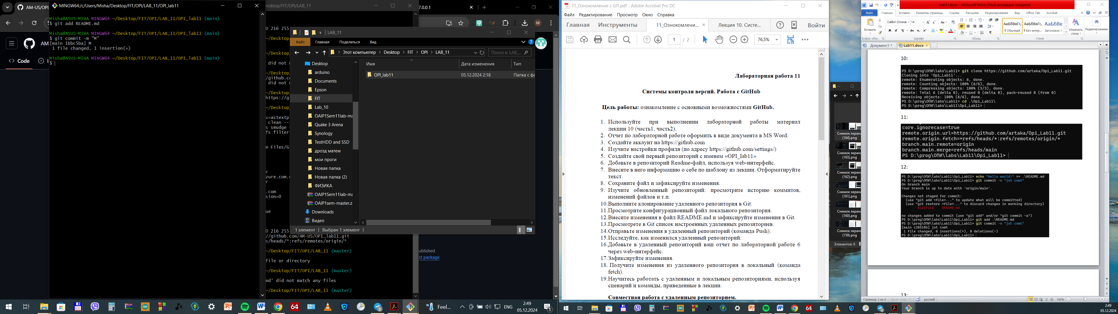

13:

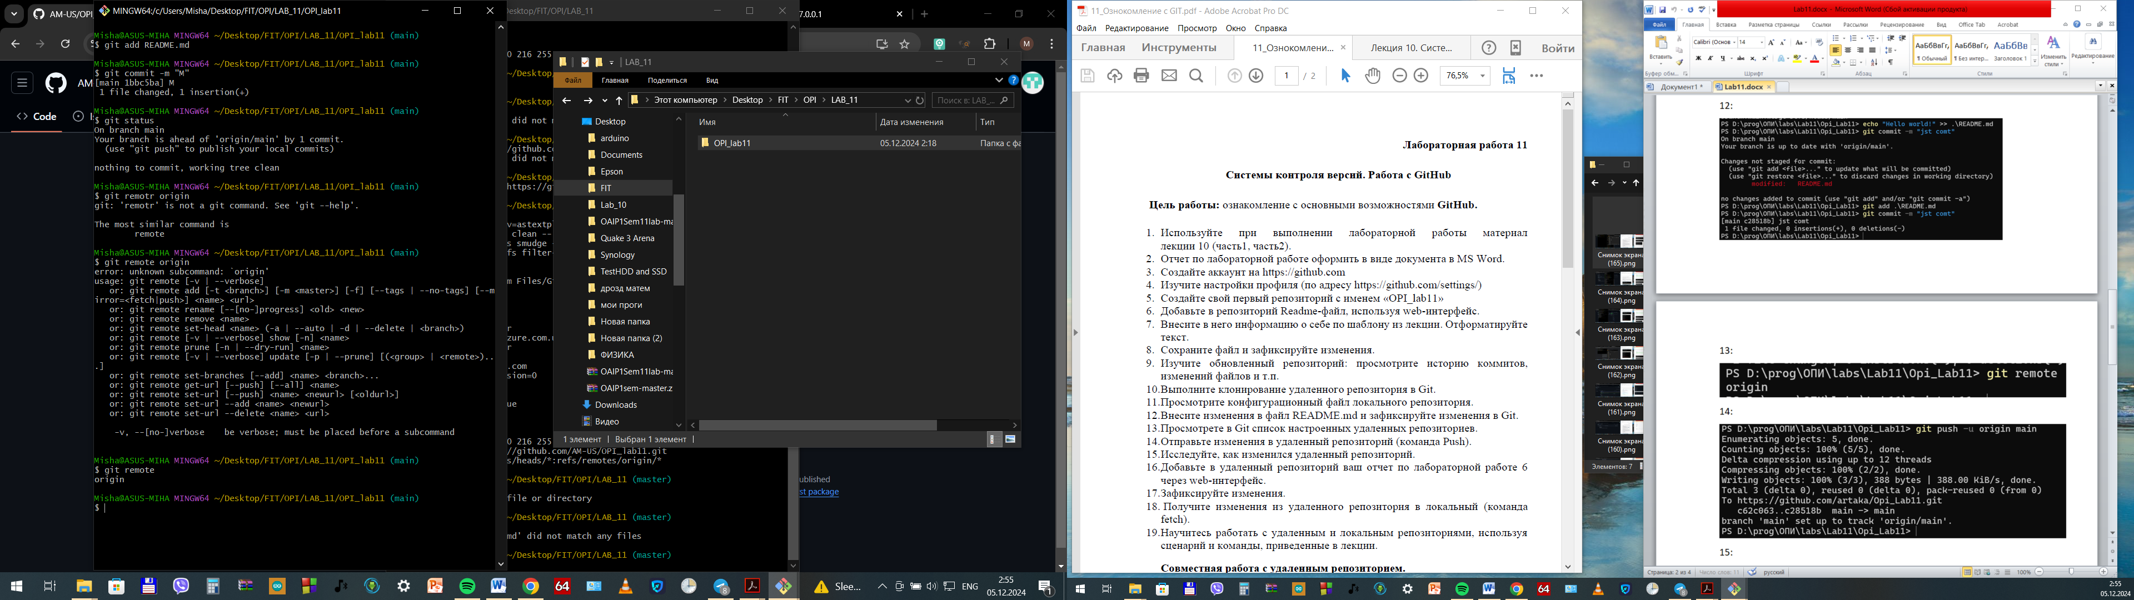

14:

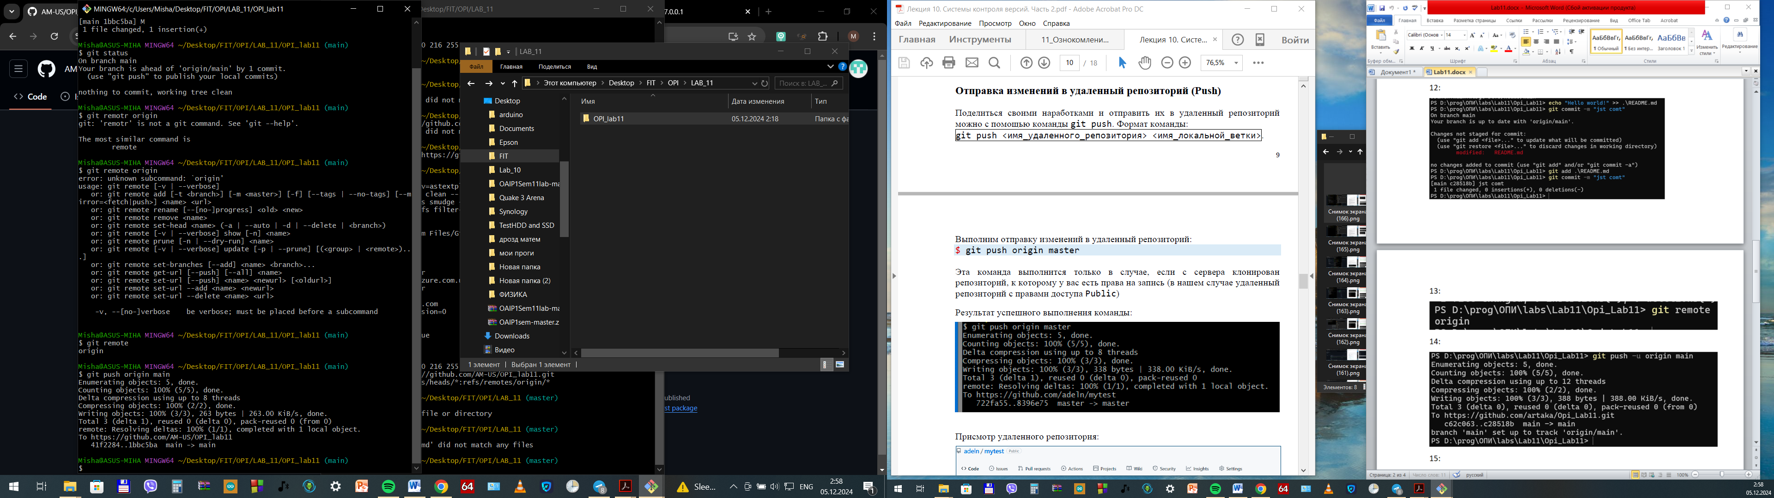

15:

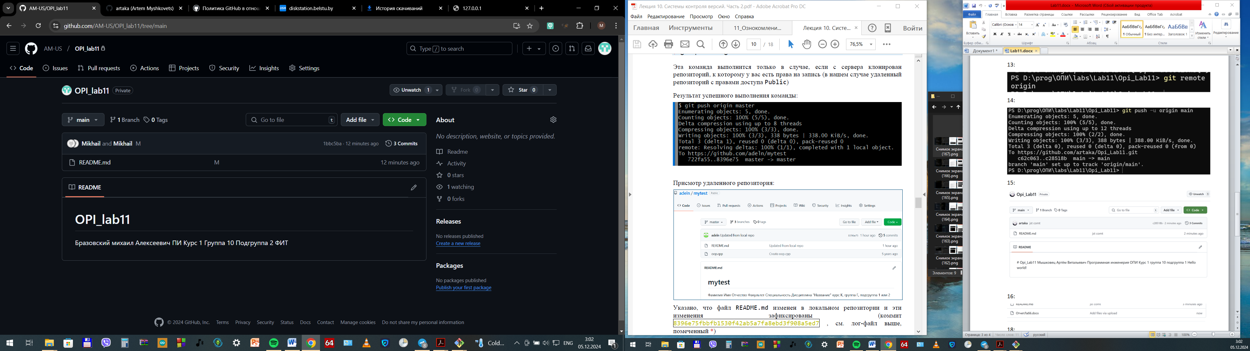

16,17:

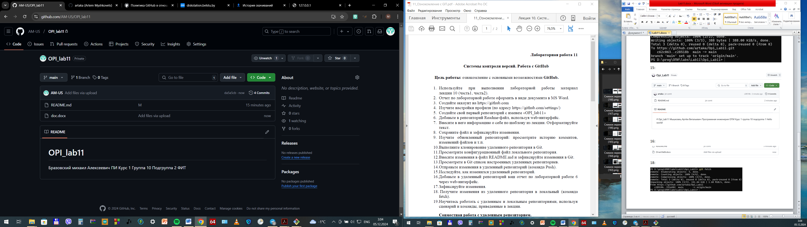

18:

